Melodies

Web programming class project 2022/2023

|  |  |  |  |  |
| --- | --- | --- | --- | --- |
| Student Name in English | Student Name in Arabic | Student ID | Section | Work percentage |
| Raghad Rafe’ Daraghma | آية رافع دراغمة | 11924594 | 11-12:30 | 33.3% |
| Sahar abdelhaq | سحر علاء عبدالحق | 11924446 | 8-9:30 | 33.3% |
| Hala isam okal | هلا عصام عوكل | 11923859 | 11-12:30 | 33.3% |

Date/time

---------------------------------------------This section is intended for the Instructor---------------------------------------

|  |  |
| --- | --- |
| **Topic** | **Mark** |
| Project Idea |  |
| Project Complexity |  |
| Project Tools |  |
| Project Requirements and Modeling |  |
| Project Discussion |  |
| Project Completeness |  |
| Project Output Results or reporting |  |
| Project Administration and Management |  |
| Project Report |  |
| Team work |  |
|  |  |
|  |  |
|  |  |
|  |  |
|  |  |

**Abstract:**

Melody is a project for music, enjoyment and allowing people to book their orchestra tickets from their homes, and the user can also buy a variety of musical instruments all through the Internet and with the click of a button.

**Content:** Introduction………………………………………………..3

Project Requirement ……………..………………………..4

Tools Used………………………………….……….............5

Project UML…………….……………………………….….6

GUI Discussion……………………………………………..7

Conclusion…………………………………………………39

References……………………………………………….…39

**Introduction:**

At first, we designed a website called Melodies. This website has two interfaces, one for adminstrators to let them add other admins, delete admins and update admins information. Adminstrators also responsible for adding tickets for orchestra, or update information for specific orchestra or delete any orchestra they wanted.

In addition, they can do the same things for instruments. Also Adminstrators can search for specific information, or see all information about instruments, tickets, admins, users and user’s reviews.

The other interface for users, after they register, they can see which orchestra they want to watch, & book tickets if they want. After issuing tickets they can choose which seats to set on from the available seats. also they can choose what instruments need to buy, they can go directly for payment section that includes all the information about this instrument.

If the users face any problem they can send an email to our website from the contact us button to try solve their problems. Finally, in order to keep us updated, we provide a page for users to enable them left their feedbacks and rate our website to keep our website evolving and make it more friendly for users.

**Requirments:**

The database keep track of two types of persons: Administrator, and user. A person can belongs to exactly one of these types. Each person has a name, personal Email, and email address.

Every administrator has a unique Email and a password and him or her responsible for adding Orchestra ticket to be shown, each orchestra has a unique name, show day and date, hall number, photo, price and description about this orchestra tickets , also he or she can add new types of instruments each type has a name and a price, description, photos, unique code

Each user has a unique Email and a password, he or she can choose which movie he want to watch, then he can issuing tickets for the chosen Orchestra each ticket has a unique name every users can show the whole instruments and tickets the book or buy.

**Tools Used:**

1. Drawio for creating EER diagram.
2. PhpStorm 2021.2.2 for bulding our website.
3. XAMPP control panel.
4. Zoom for making mettting.
5. W3schools.
6. Flaticon and iconify.design for icons used in project.
7. Removebg and cutout.pro for removing background from png image.
8. ONLINEGIFTOOLS for removing background from gif image.
9. Youtube.

10.Stackoverflow.

11.Word document.

12.Text document.

13.paint for resizing images.

14.Pinterest.

**UML Diagram:**

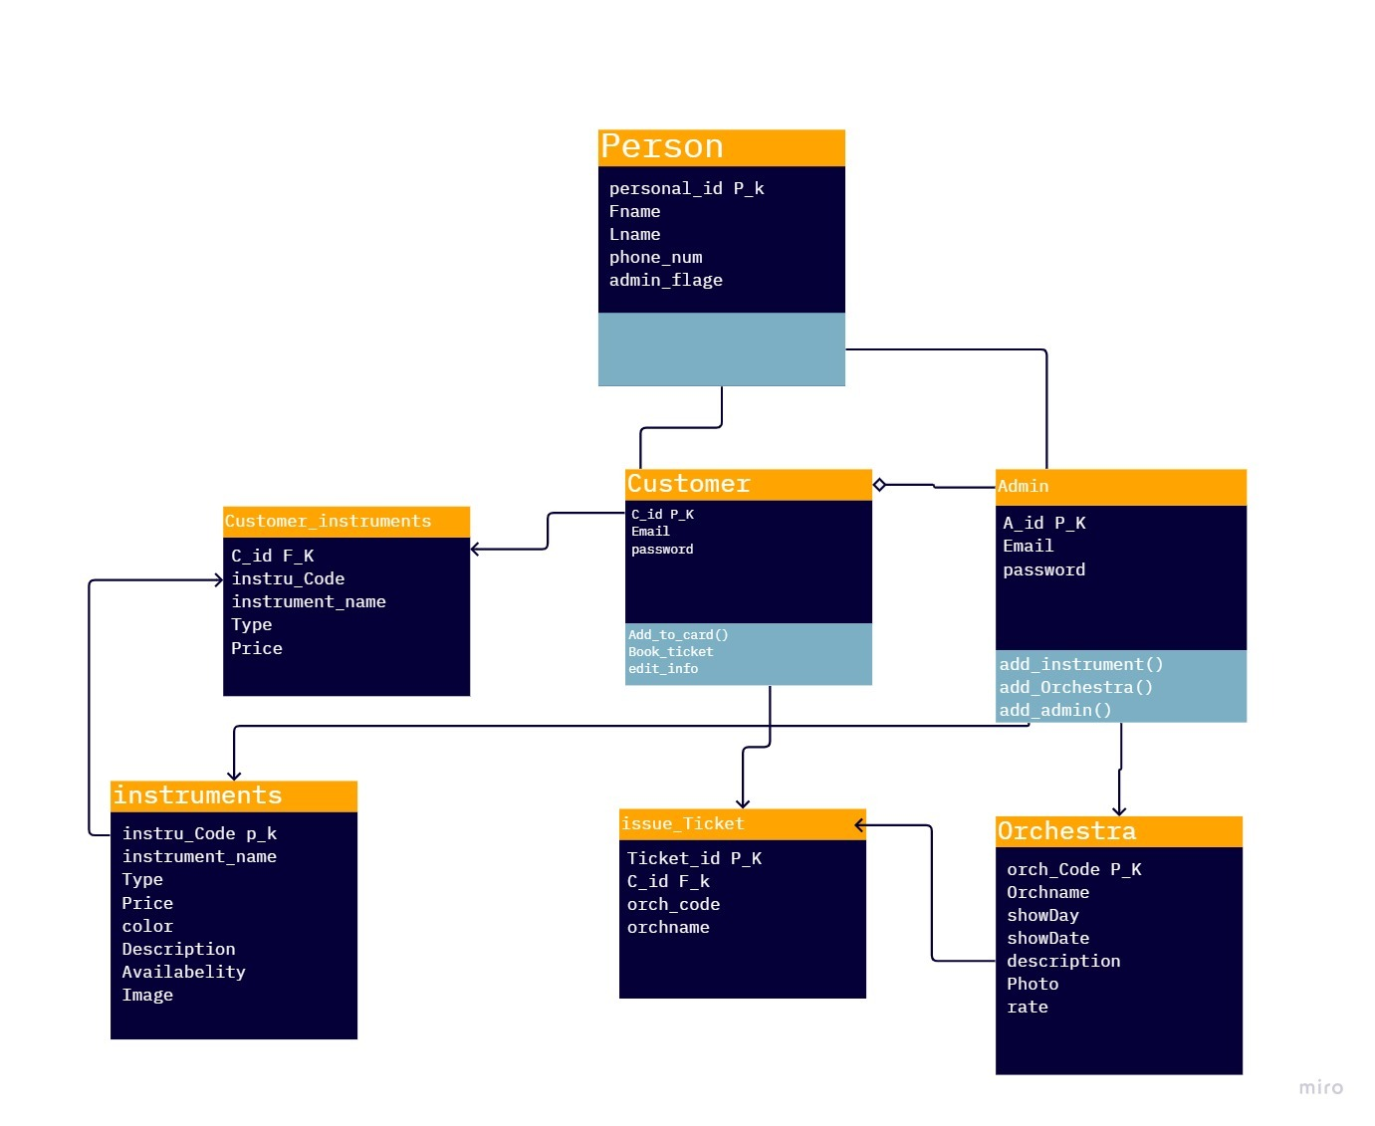

**GUI:**

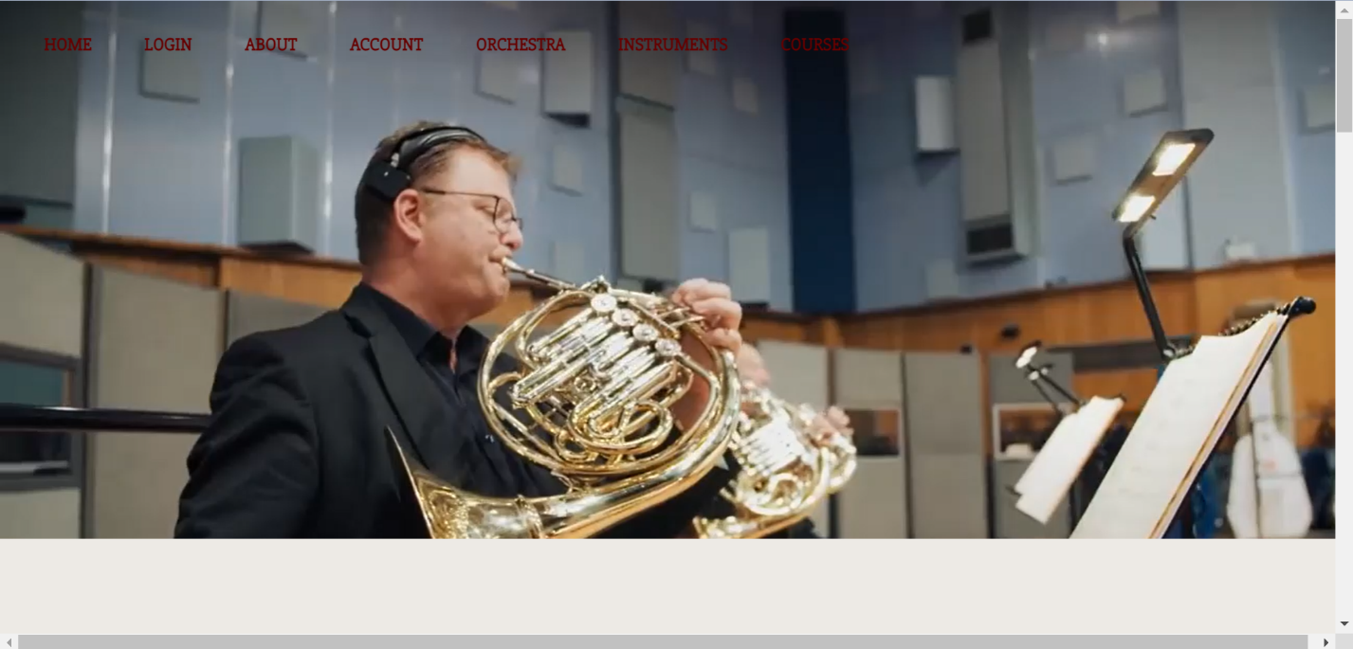

This is the first interface in our website it includes navbar at the top of the page, on video show that includes some photos. When users scroll down then the below interface will appear.

click login from the navbar, and login as user:

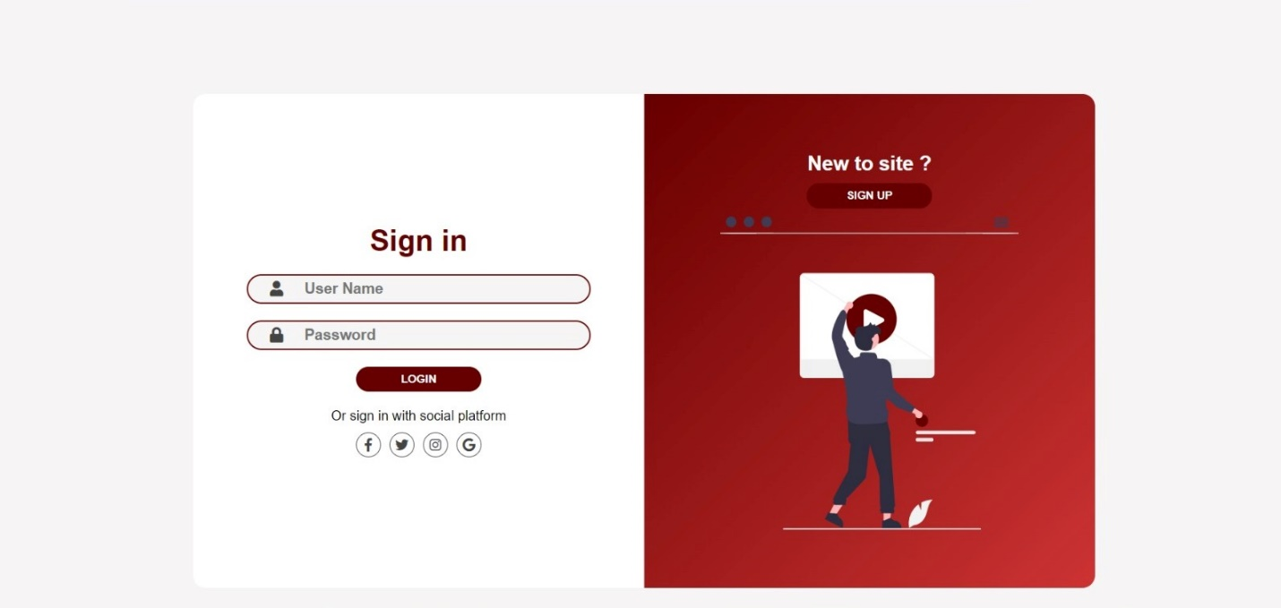

and if you don’t have an account you can sign up in our website:

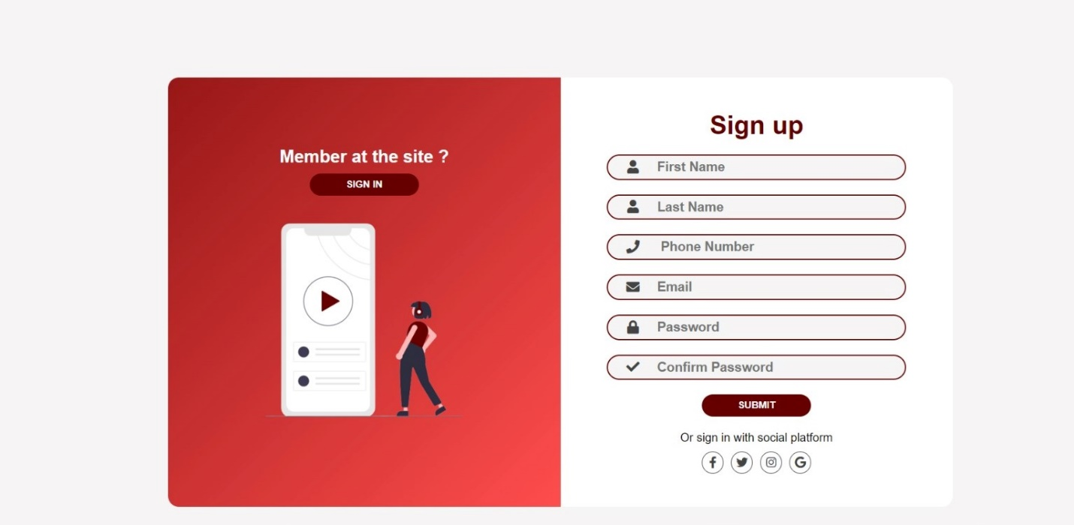

After login in with your correct password and email,

Scrolling in the home as user you will find ocrhestras and you can book a ticket, and instuments to buy

Our ochestras will appear here in a slider show, if you shoose any one a page of its details and how to book a ticket fot it will appear, then then after book your ticket, your reservation will be added to the database of our website

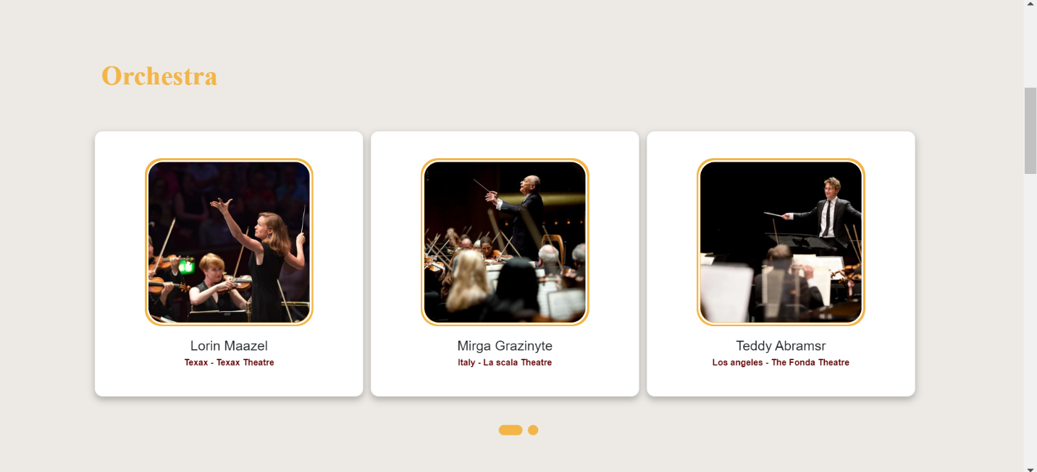

This page at the bottom shows all the orchestras that we have and enables the user to choose the concert he wants to know its details and book a ticket

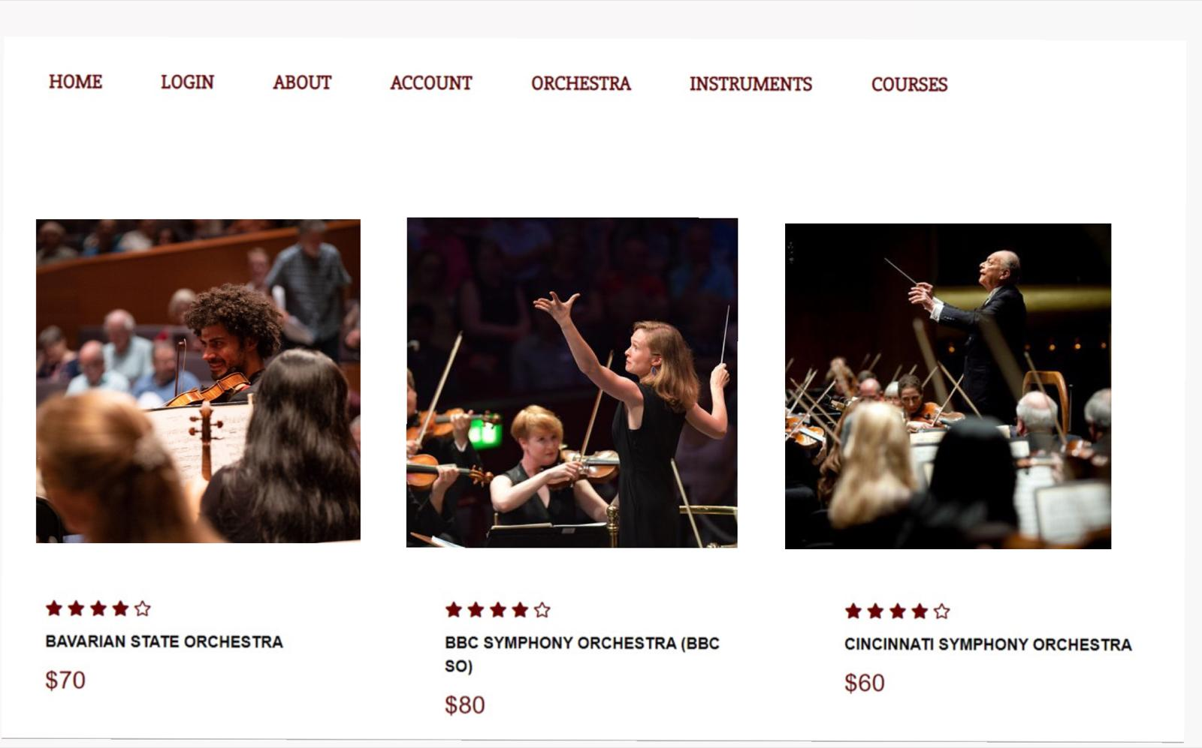

If you choose the first one for example a page of details and booking a ticket for it will apears for you:

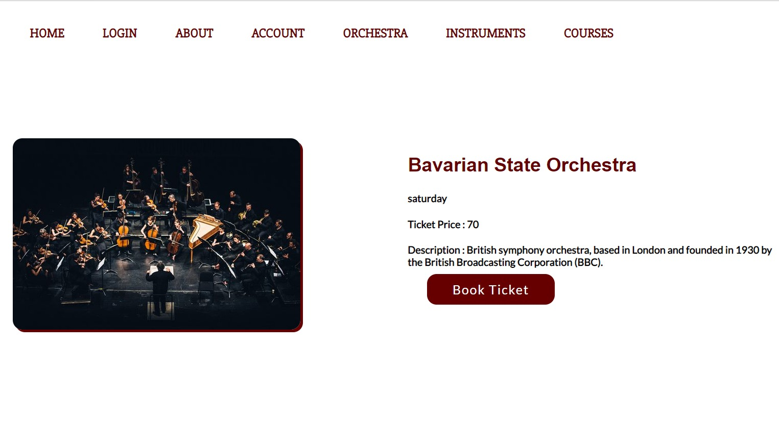

Get back to the home page and continue scrolling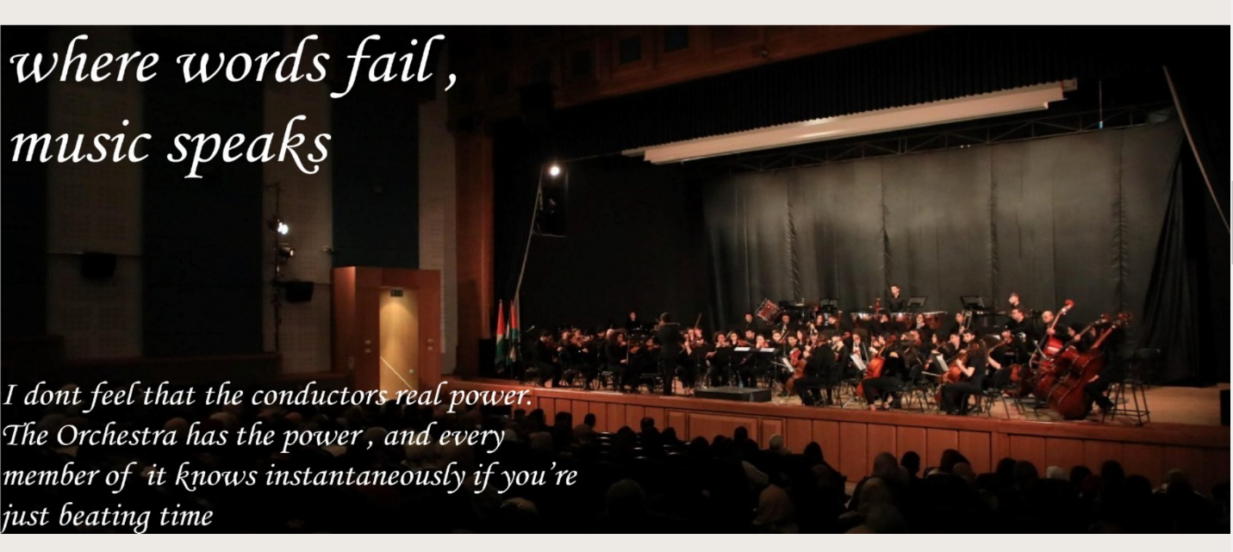

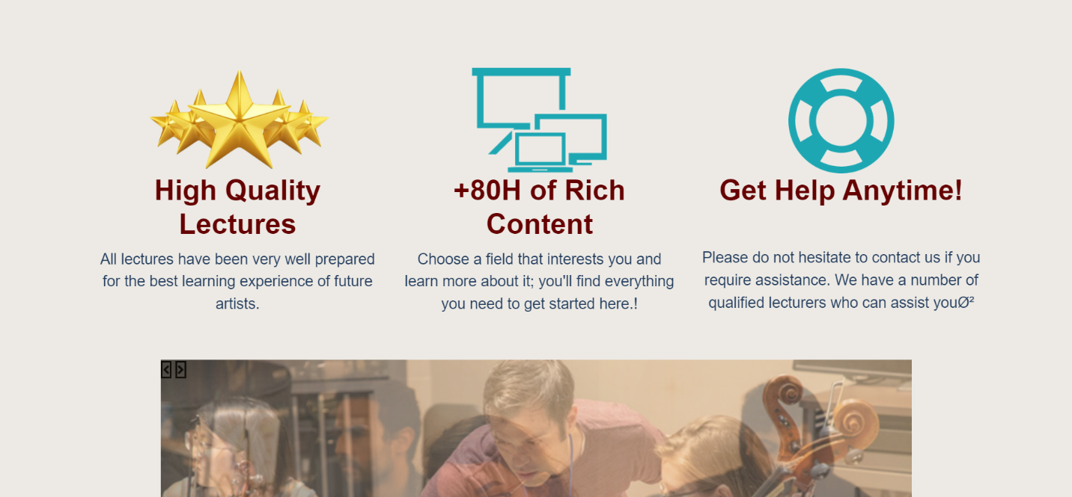

Slider photos about our **melodies** world!! *-*

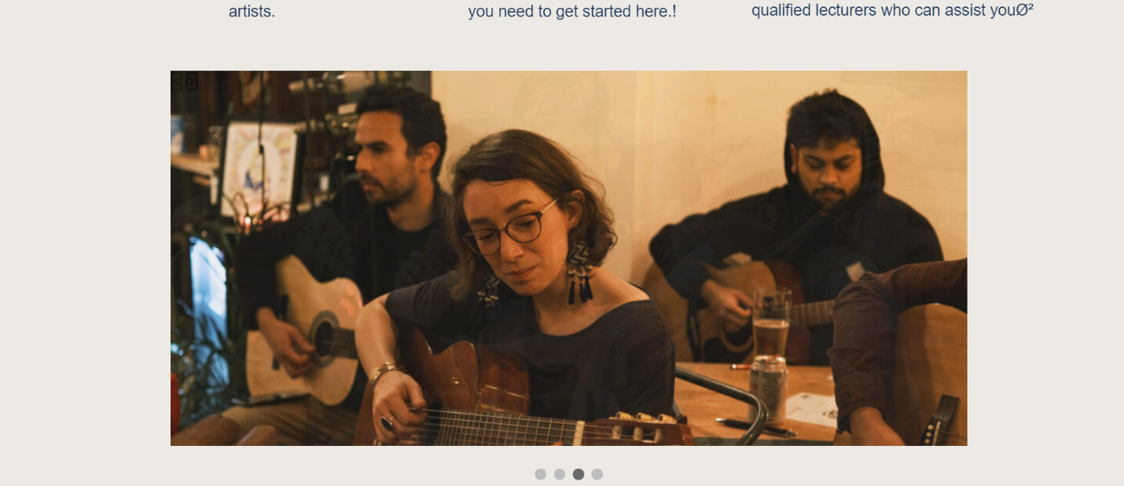

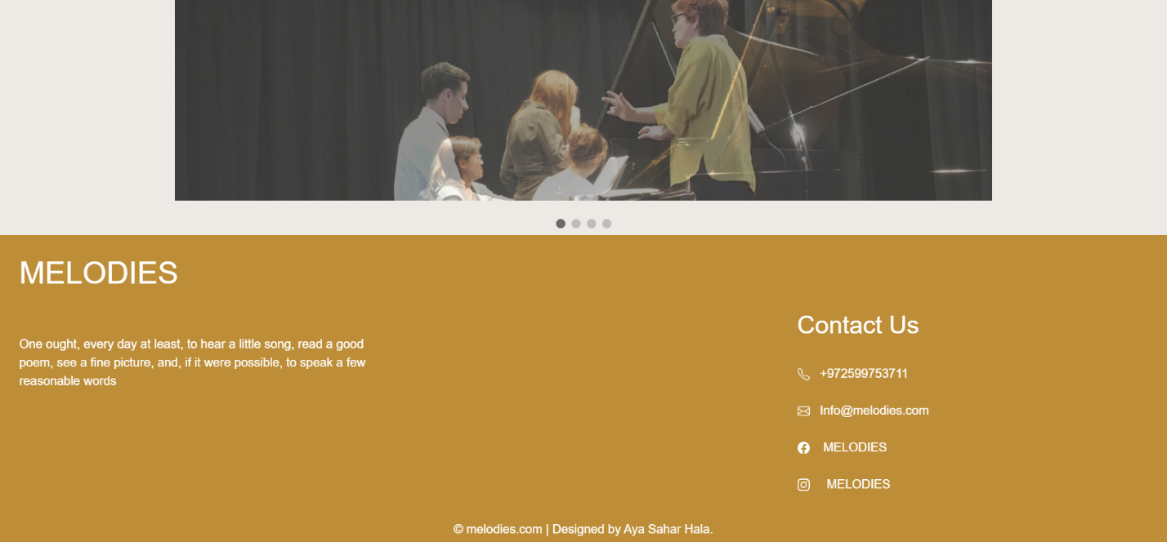

Then you will reach the musical instruments

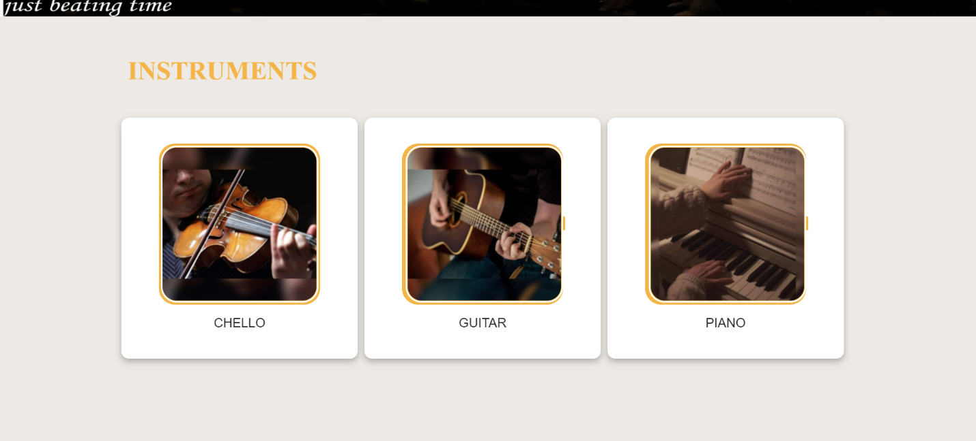

If you choose the piano, you will be presented in a dynamic way with a page containing several piano instruments at different prices and additional details, for purchase and if you buy a tool, it will be added to your basket on the user profile page.

Instruments pages:

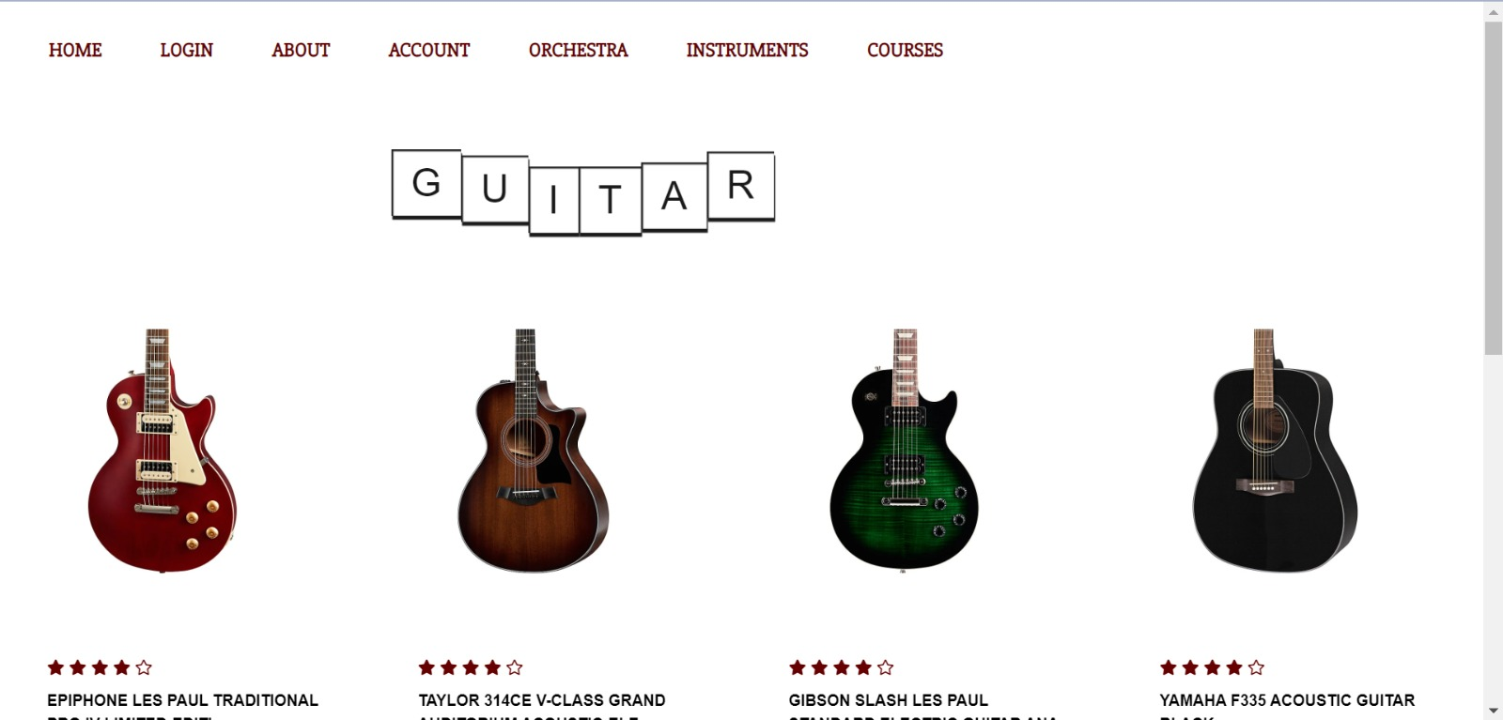

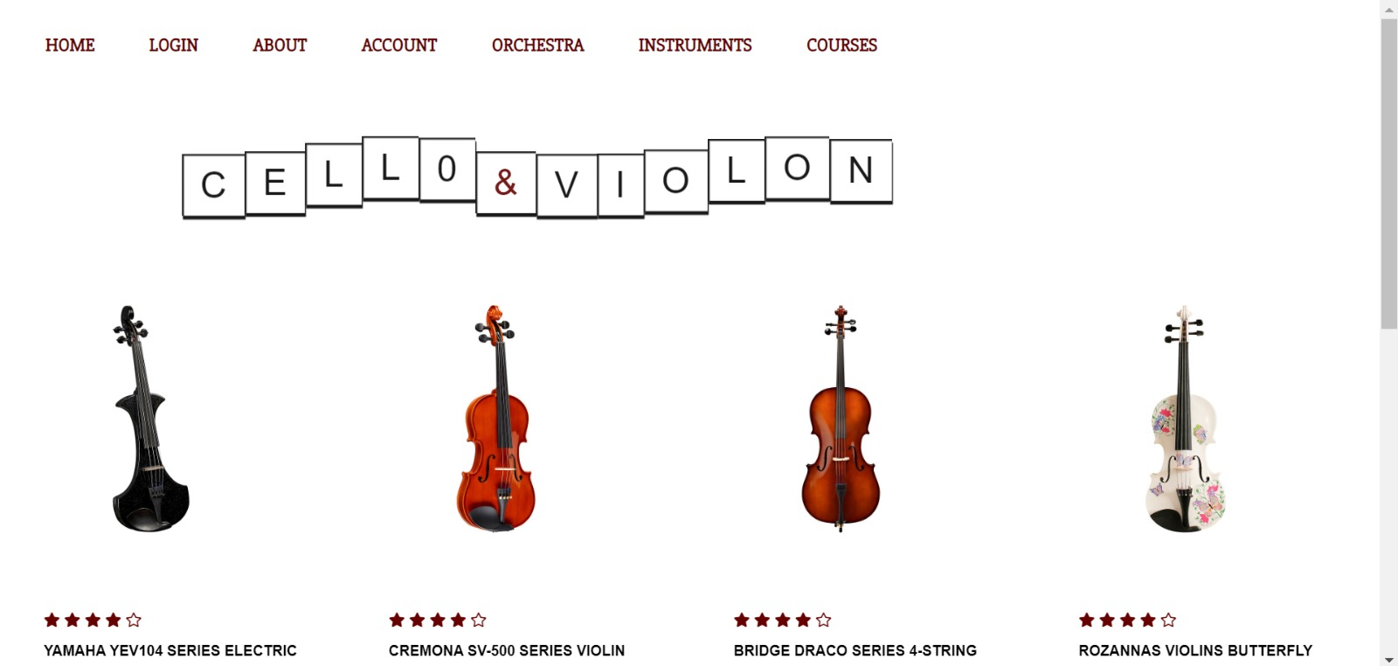

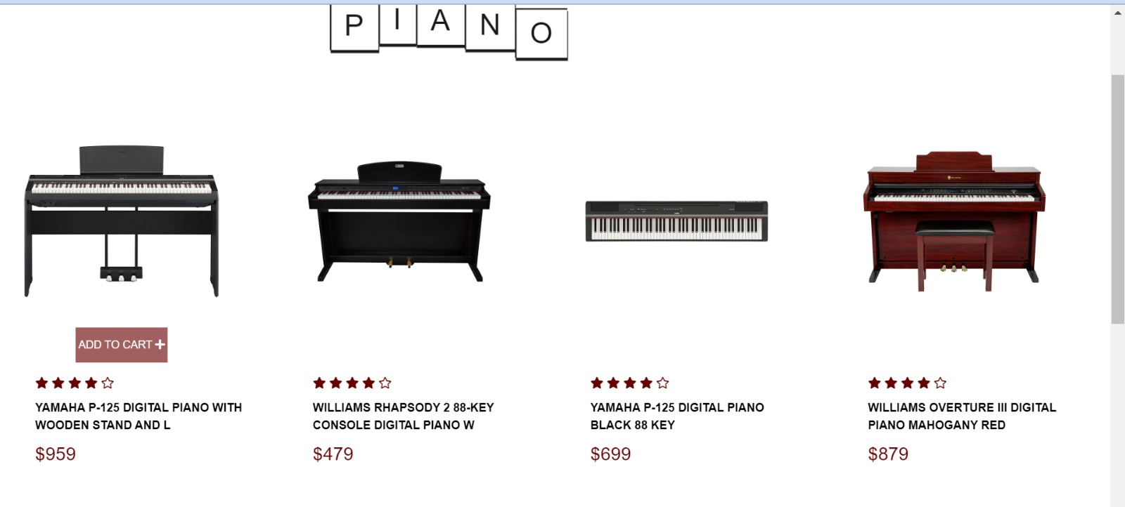

Sub product page :

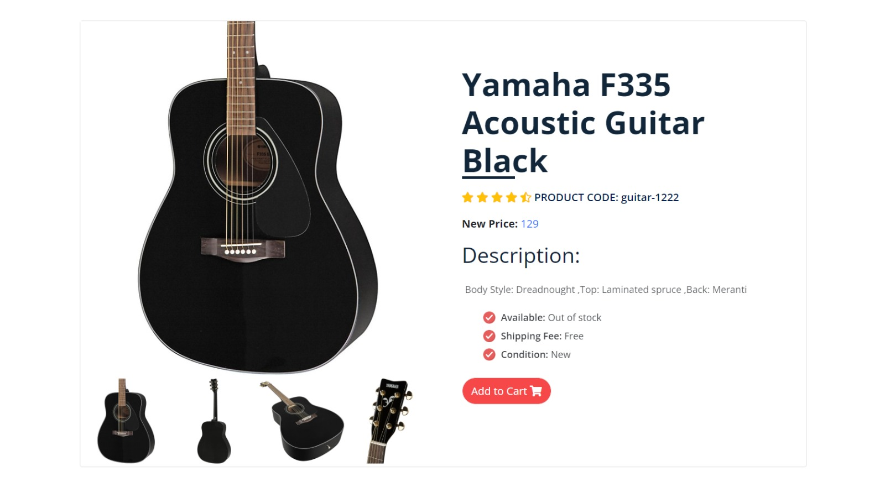

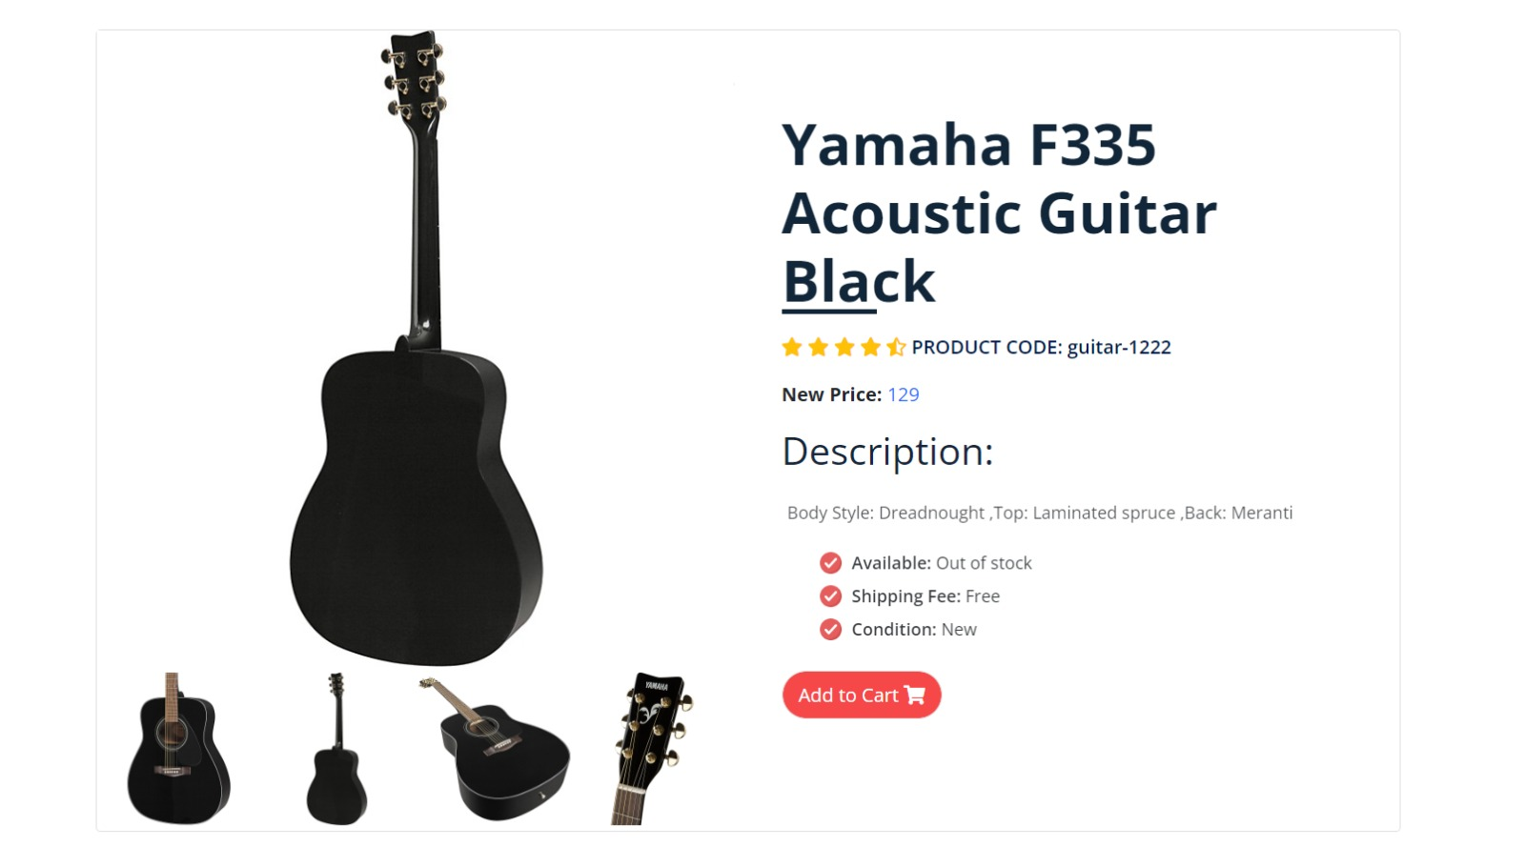

And this interface will be repeated in a dynamic way for the 17 instruments that we have or more - if the admin wants to add -

there are 4 other pictures that show the details of this piece from its sides to enable the buyer to get to know the piece well and can move between them easily as it appears in the pictures at the bottom of the page

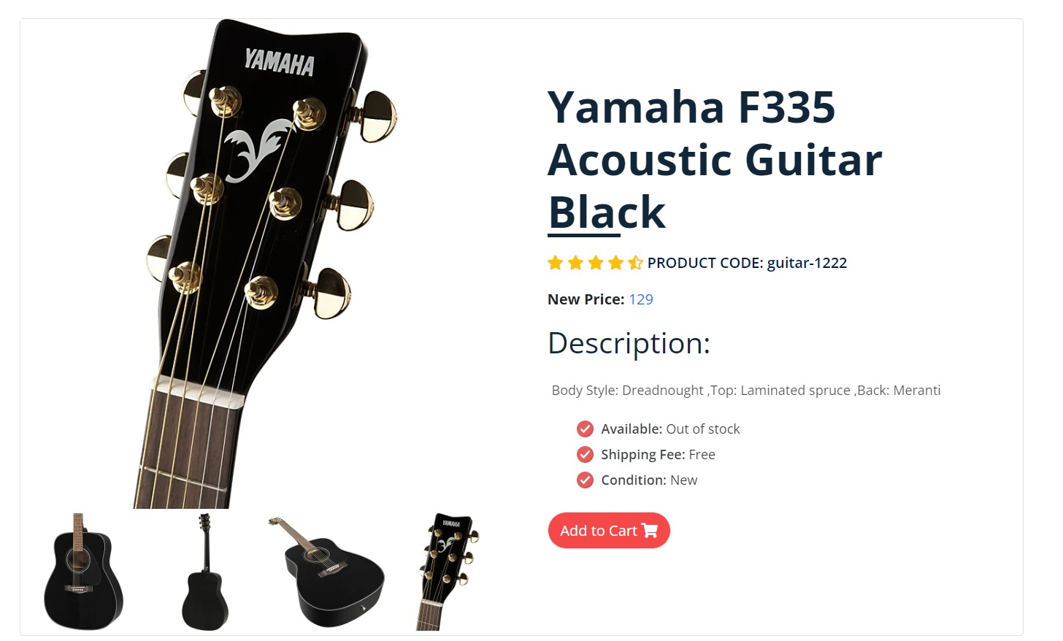

About users profile it will It will show the user his information, what tools have been purchased and the tickets he has booked

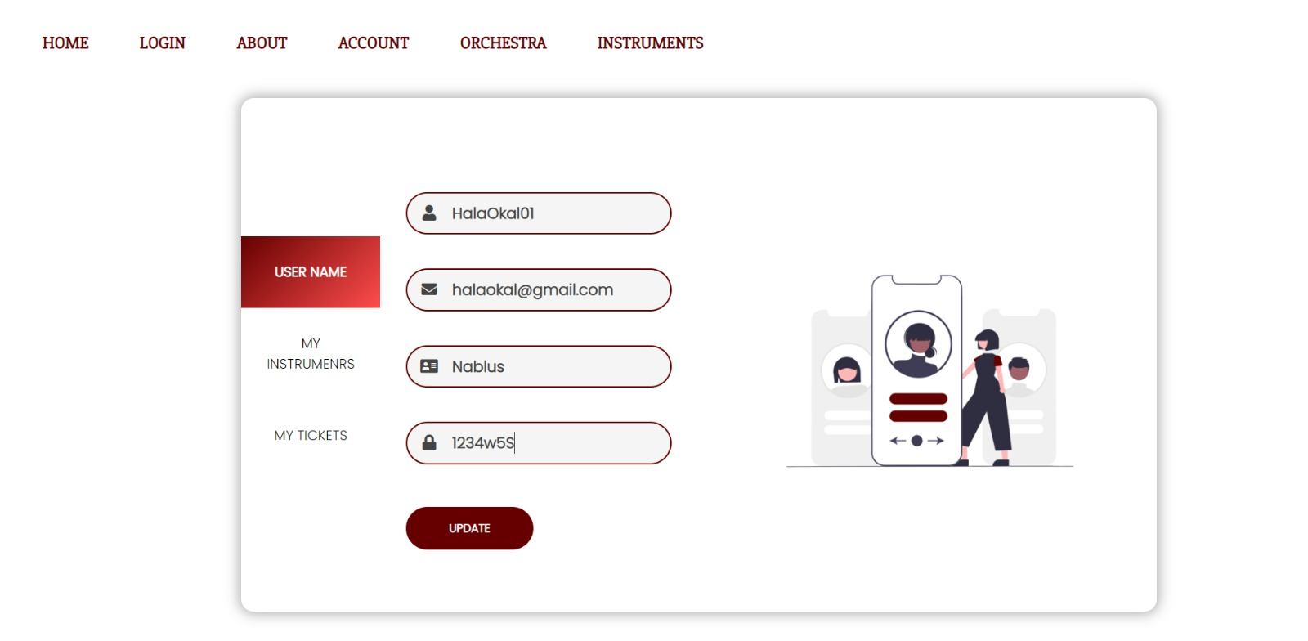

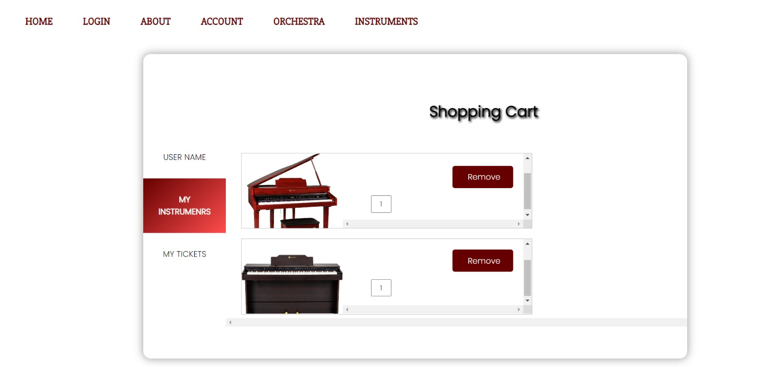

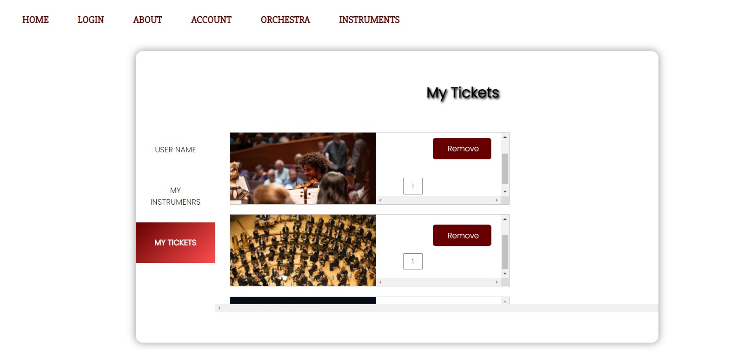

**Now let us move to the administrator interfaces:**

If an Admin log in with correct username and password, a dashboard page with the website information will apears as shown:

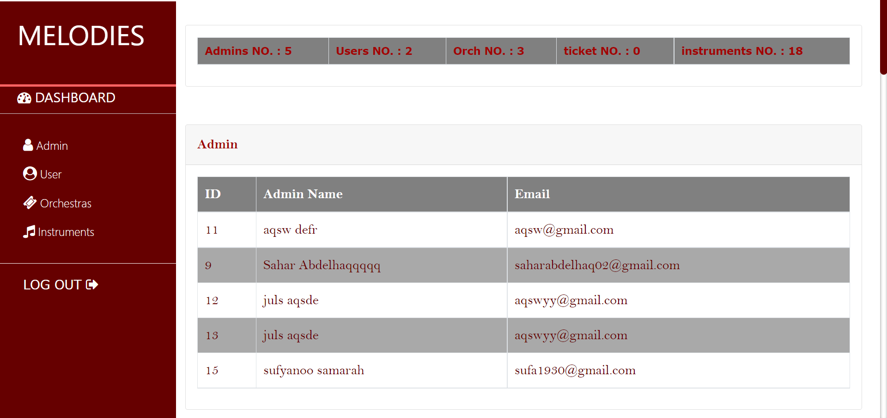

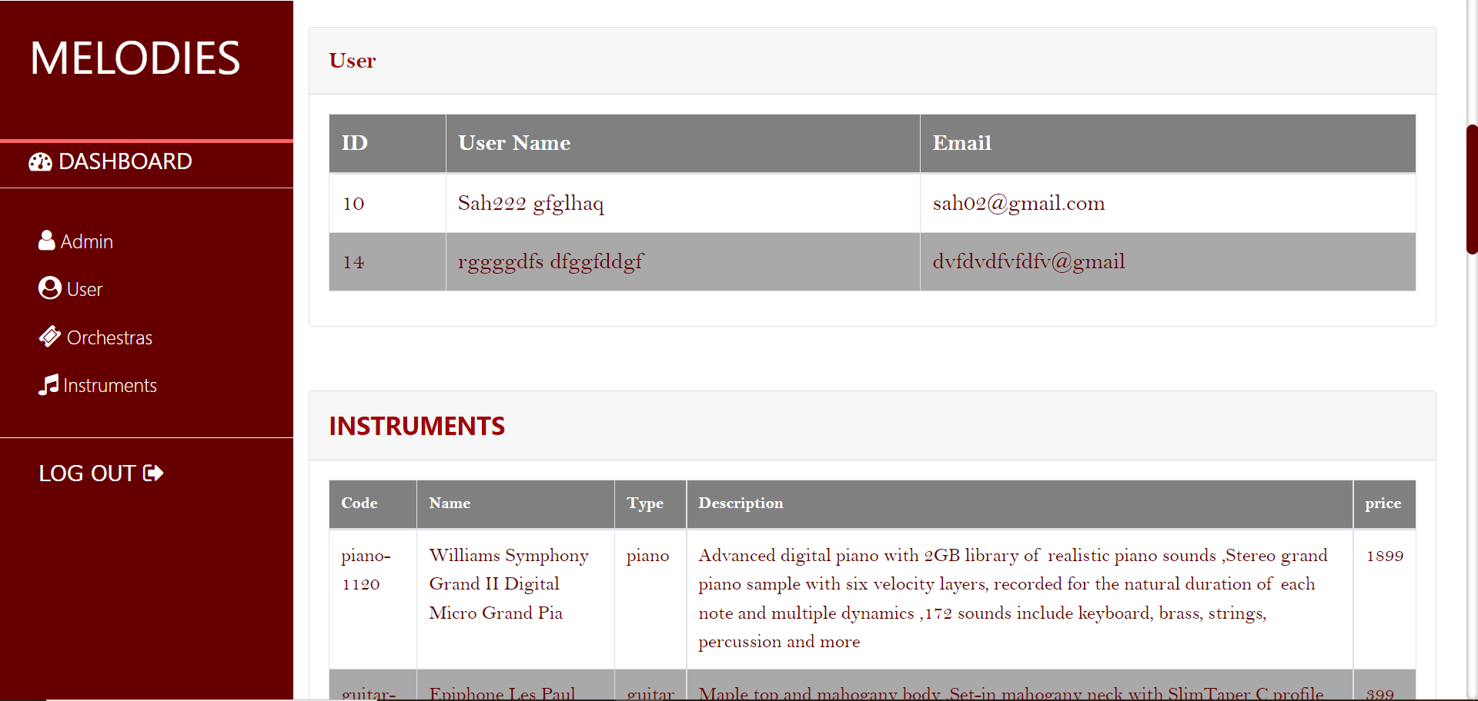

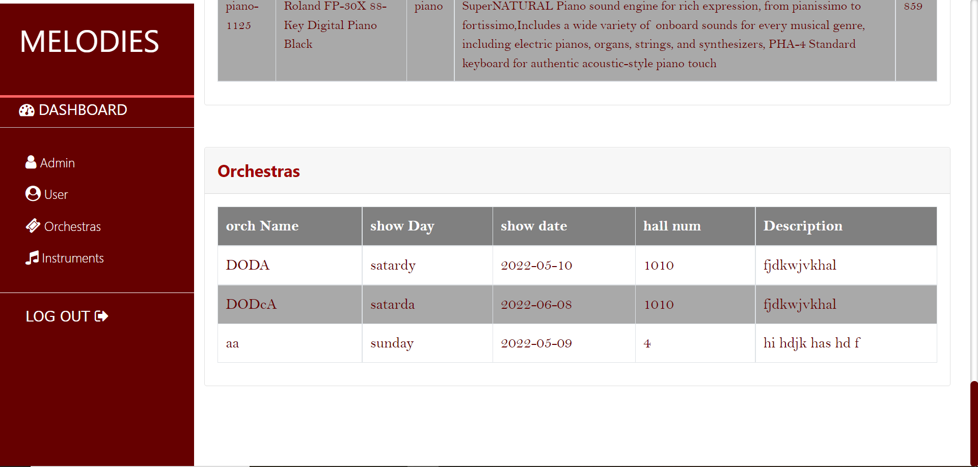

If Admin button of the navbar clicked:

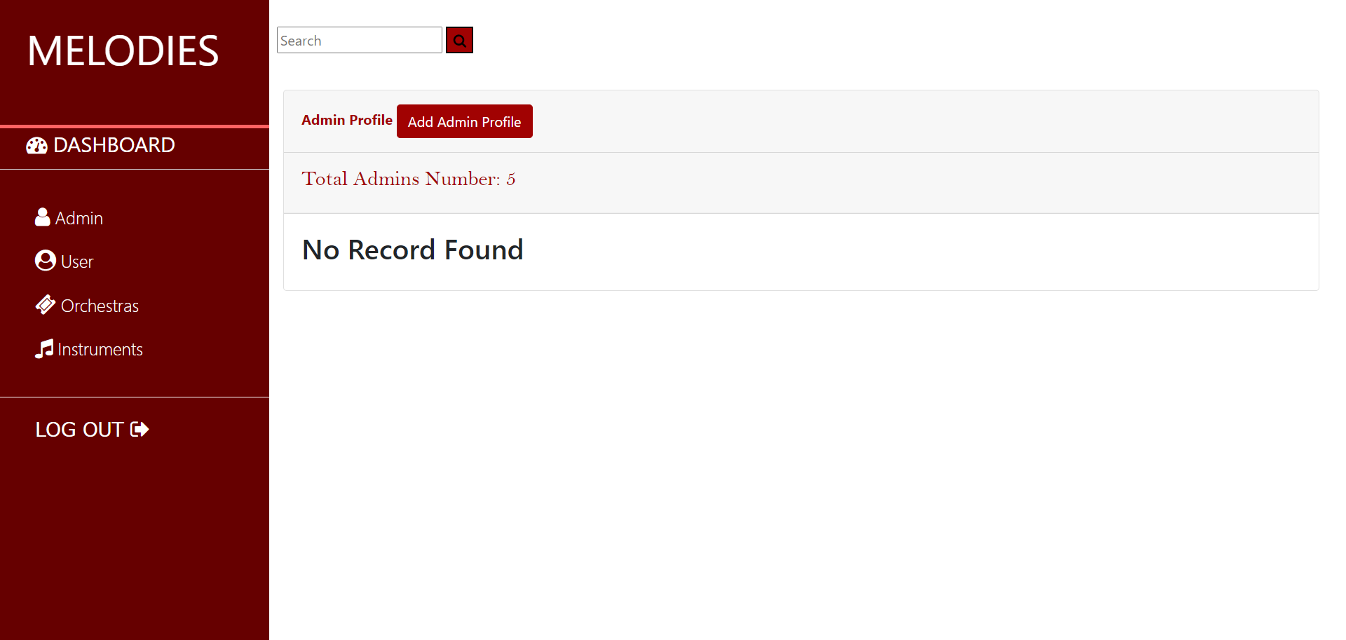

the admin can search by an Admin name for other Admins and show some of there information to edit also for delete if nessery:

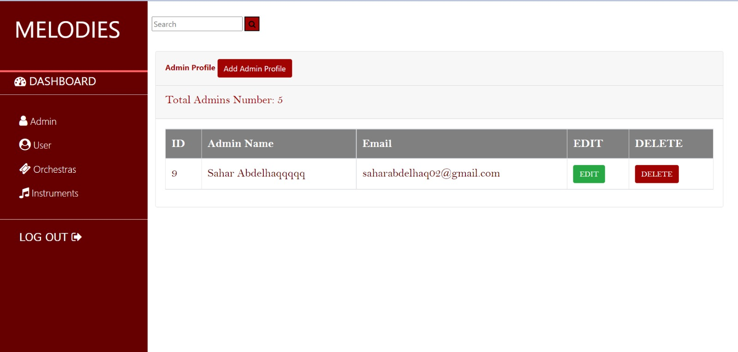

If edit button clicked:

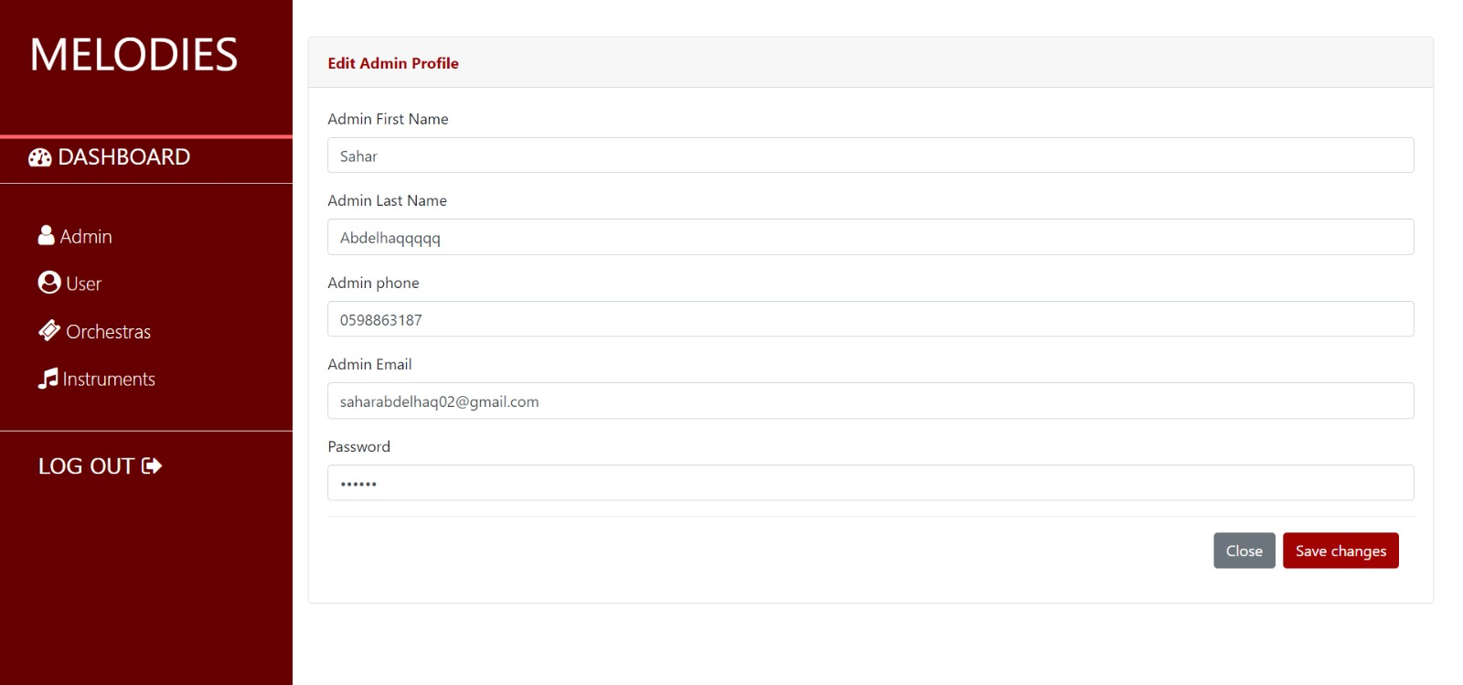

If Add a new Admin button clicked, so Admin Can register a new admin in the website after filling all fields:

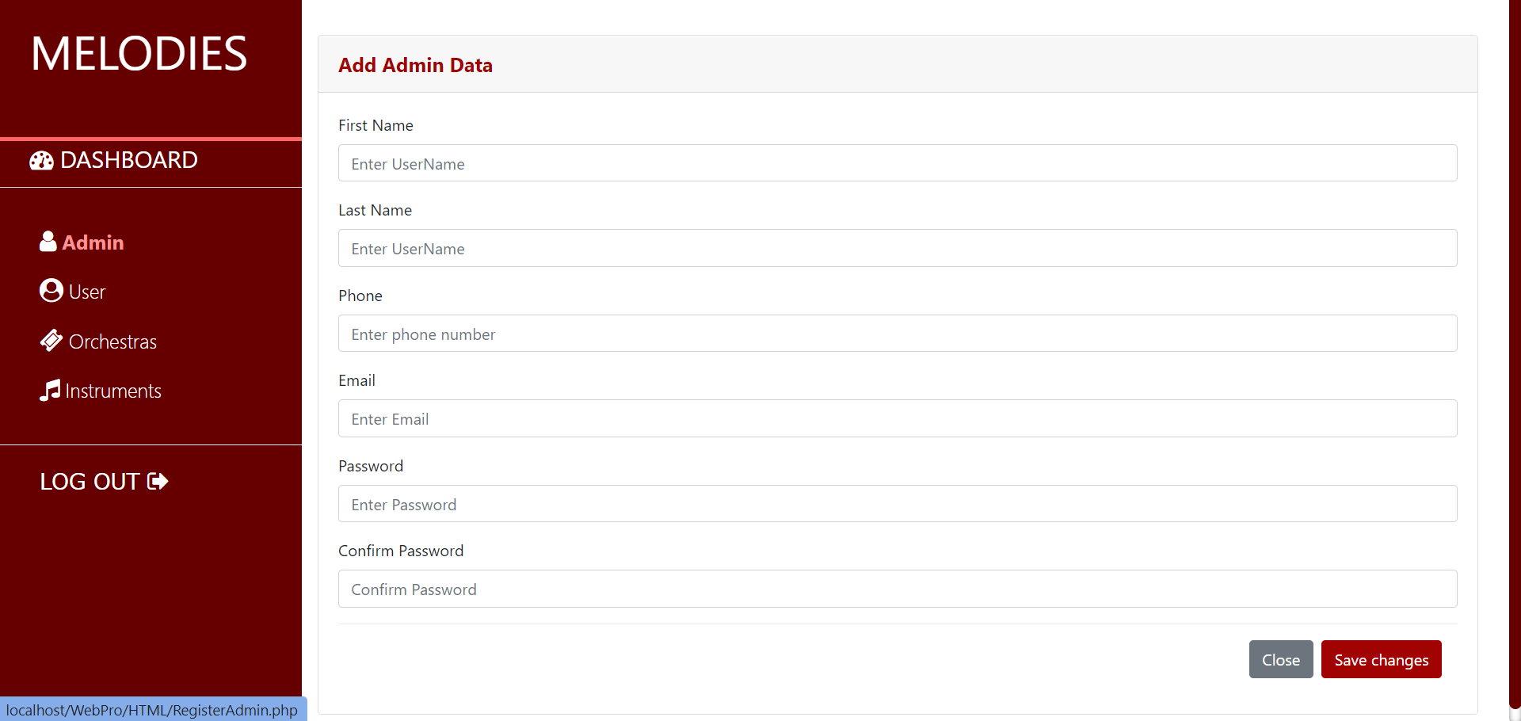

Then, if button user clicked, admin can see users general information like username, ID..

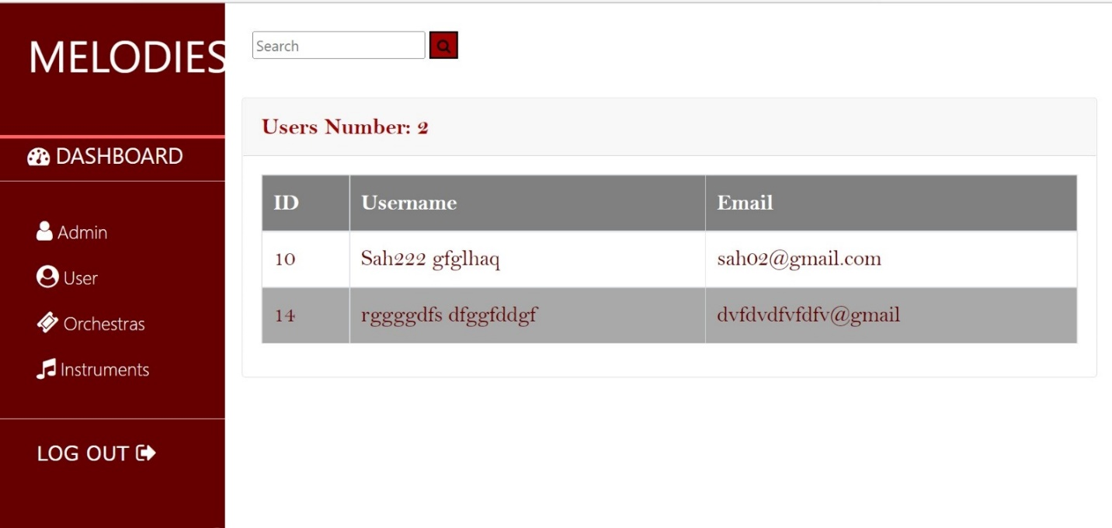

If orchestra button clicked, admin can add a new orchestras and show other orchestras information, edit and delete can update the orchestras in our website:

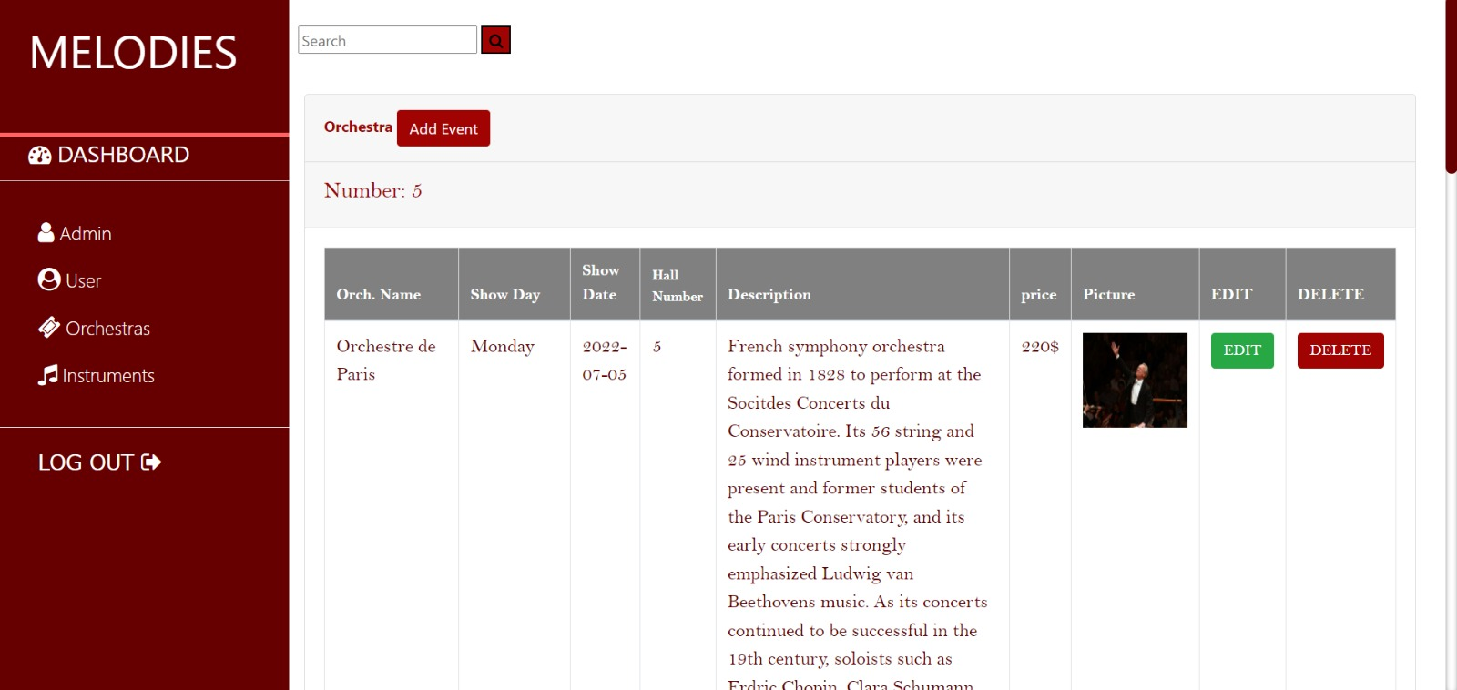

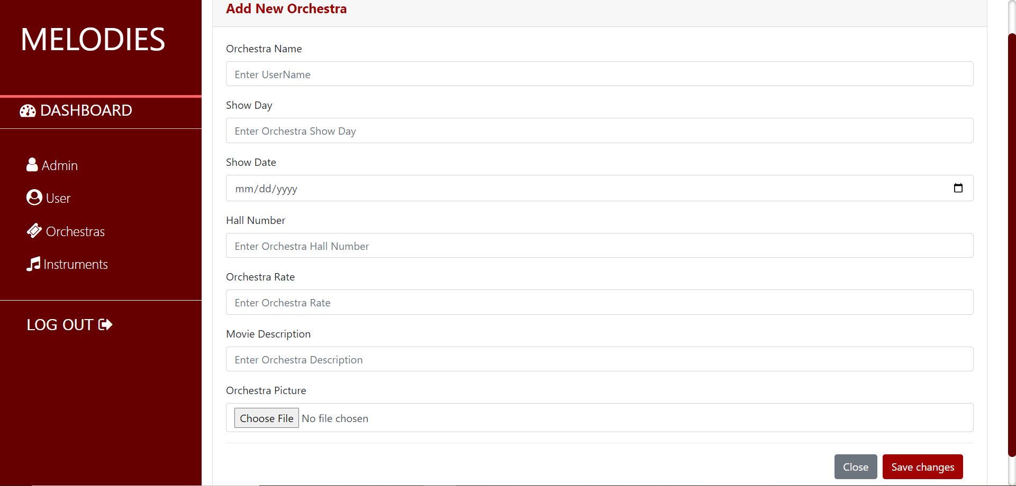

If Instruments button clicked, so the admin can also search,edit,delete and update instruments information:

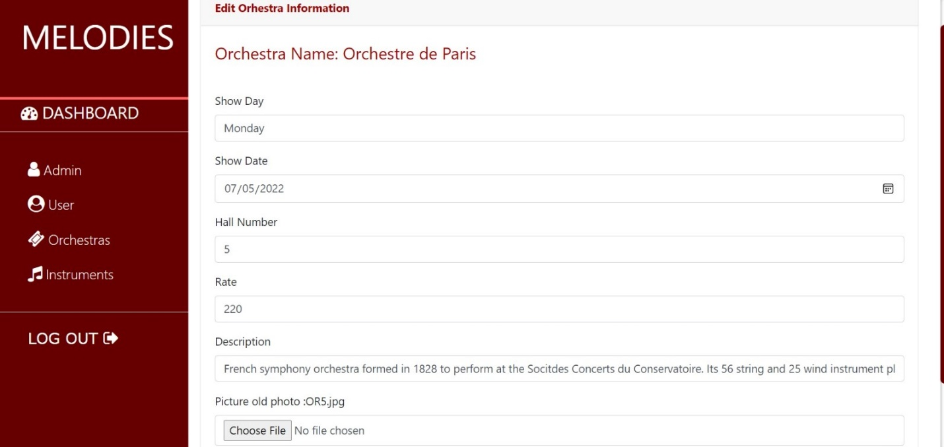

If delete button clicked:

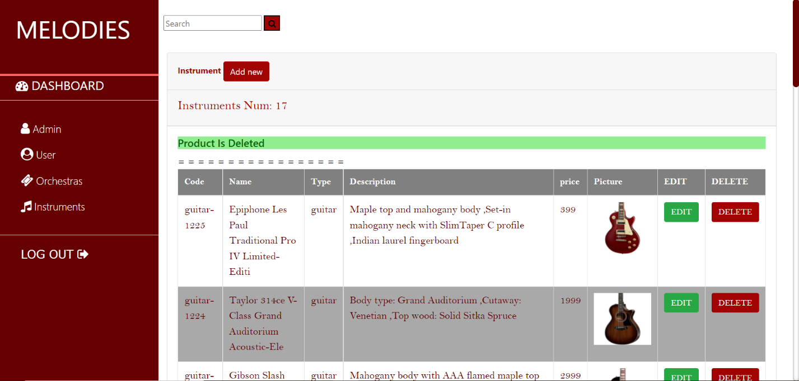

If an edit button clicked:

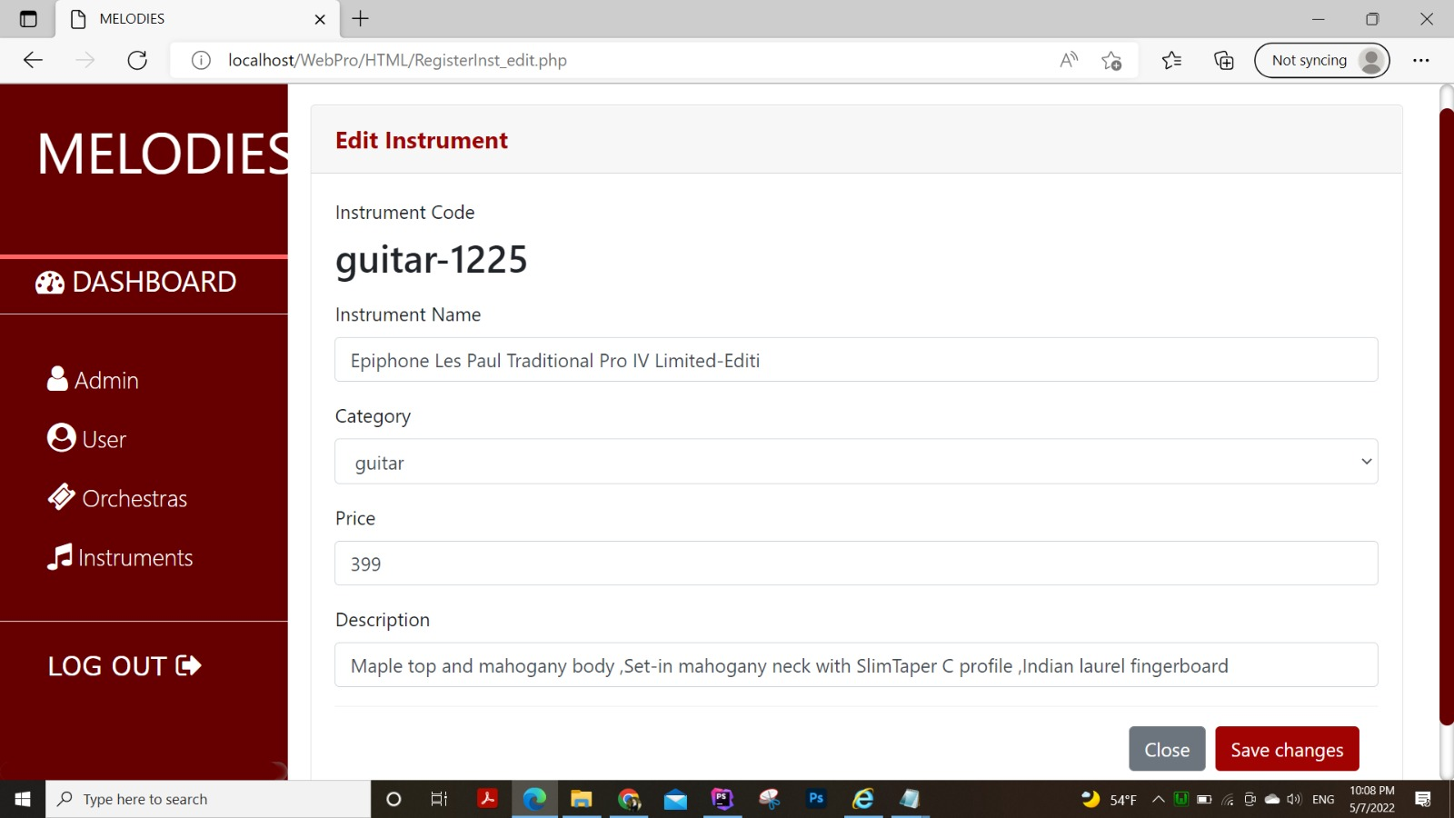

The bellow image show **“about us”** page include our social medea link with an animated music note on the left that moves..

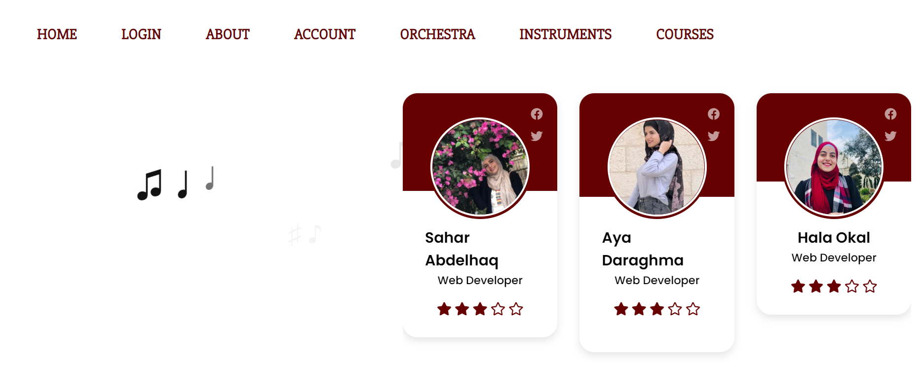

**Conclusion:**

This site makes it easy for users to book orchestra tickets that they want to watch in the easiest and most beautiful way, and they can also buy the instruments they want with all credibility and a complete display of all the details of the piece Melody is the perfect choice for everything related to music!

**References:**

* <https://www.w3schools.com/>.
* <https://stackoverflow.com/>.
* <https://www.youtube.com/>.